PROCEDURE FOR PROVISIONING OF ELECTION PLAN ON CDMA FWT
(IMPORTANT: While barring I/C and O/G over voice strictly follow the below procedure. Otherwise data access will not be possible)

- Generate an order commit and complete it for the account creation with BSNL CDMA GENERAL PLAN with Rs. 250 PDSS Data Access. Also enter Rs.600 as prepayment in Kenan FX GUI.

- In order to bar voice (Both I/C and O/G) kindly follow the following procedure. Generate a separate order with the following product…

- Goto Services → Change →

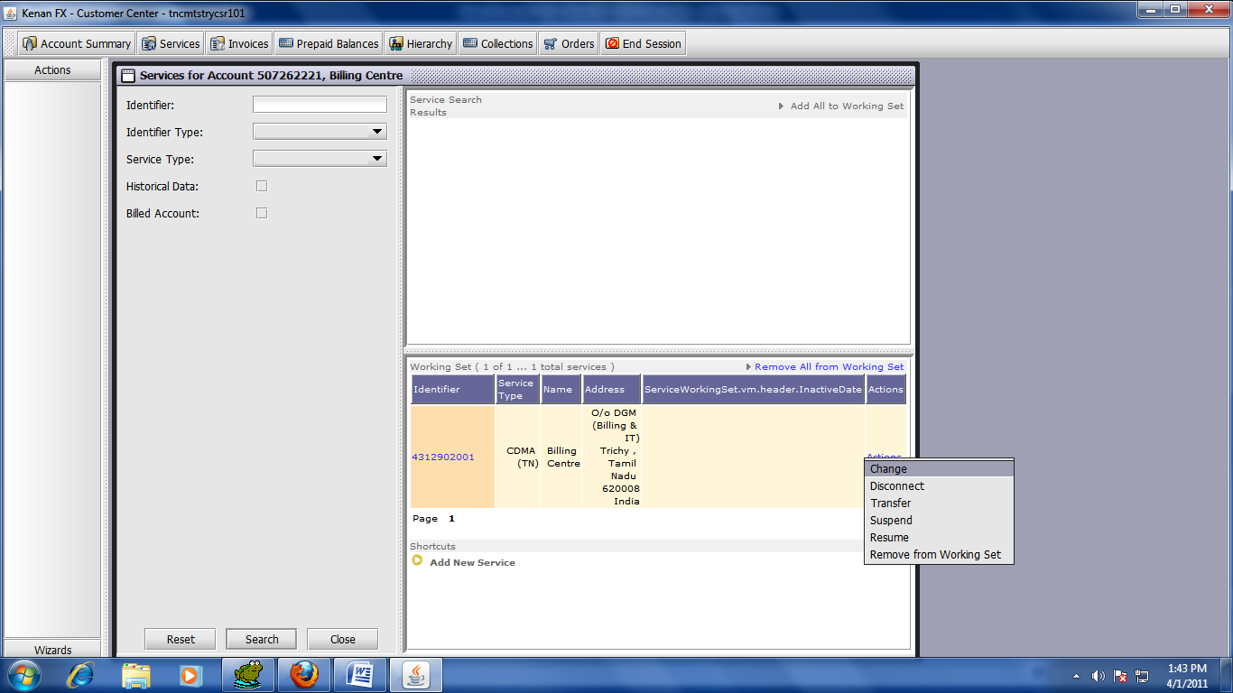

- Select A La Carte → Available Product → Product → CDMA Product Group → Select CDMA Product Line
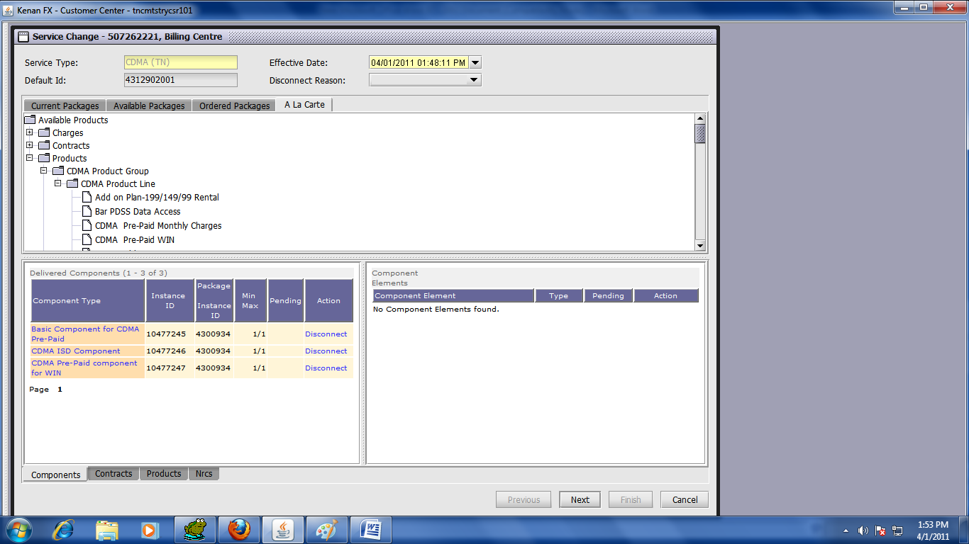

- In CDMA Product Line Select the products (1) I/C Barring with SMS (2) SULABH O/G BARRING
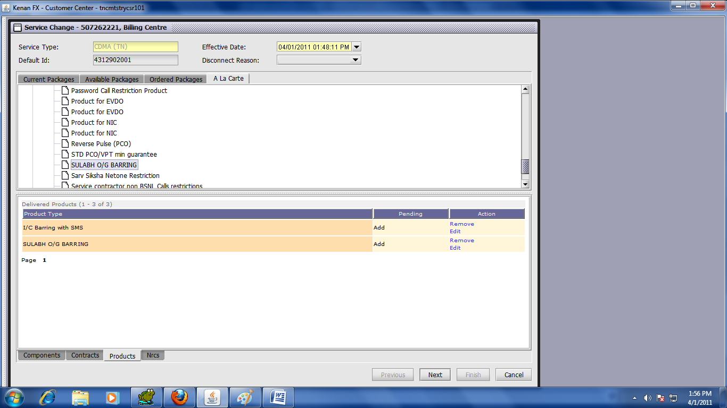

- Then as usual go Next → Next → Finish; Commit and complete the order.

